NOTE: A screen capture should contain (1) the connections panel, (2) the actual connection used (top right drop down), the (3) SQL statement and (4) the result set.

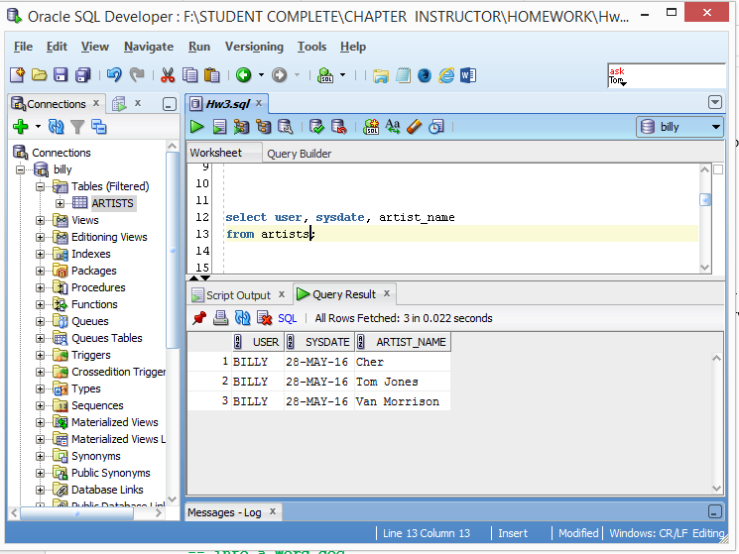

**1**

**2**

**3**

**4**